**Unix Commands**

**ls –** It is used to list the names of files in a particular Unix directory.

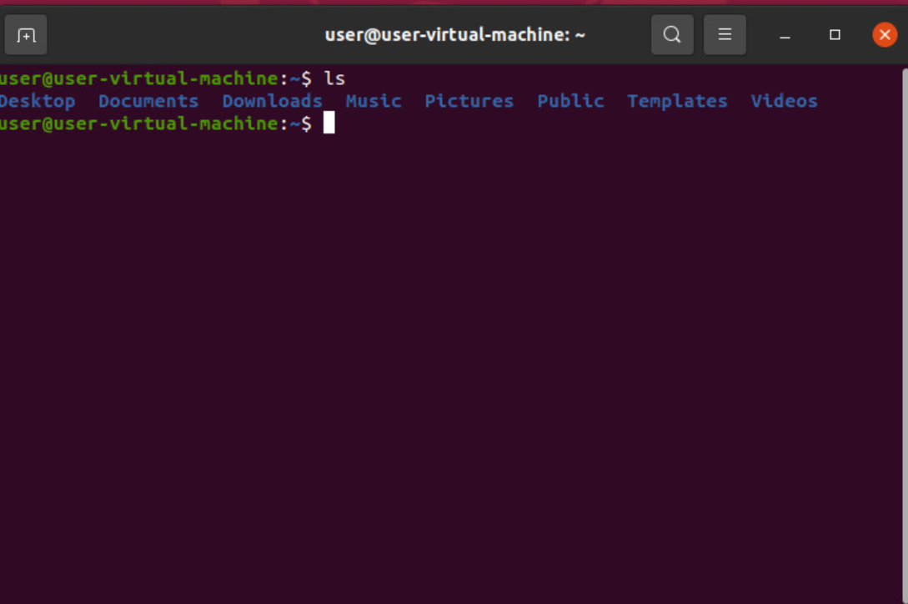

**Cd -**  It is used to change current working directory

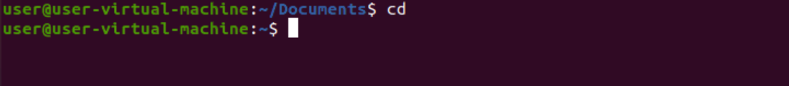

**Cd .. -** This command is used to move to the parent directory of current directory, or the directory one level up from the current directory. “..” represents parent directory.

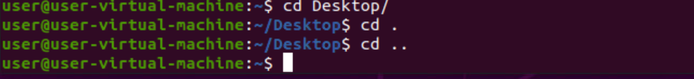

**Cd ~** - This command is used to change directory to the home directory.

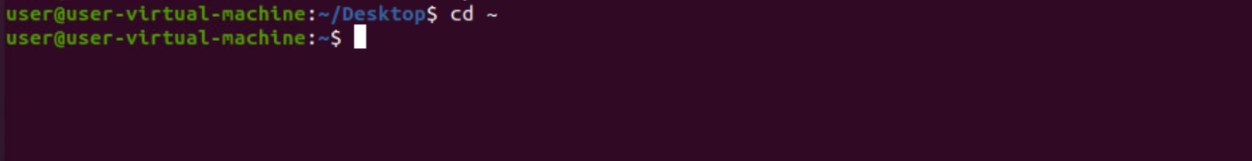

**cd /**: This command is used to change directory to the root directory, The root directory is the first directory in your file system hierarchy.



**Sudo -i** – It helps user to login in system.

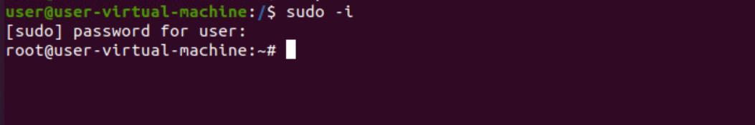

**ls -l** – It gives long listing of the files in your directory .

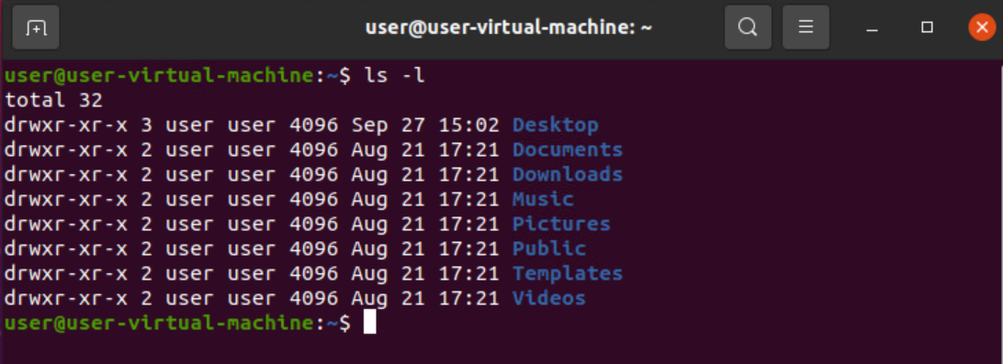

**ls -lh -** This command will show you the file sizes in human readable format. Size of the file is very difficult to read when displayed in terms of byte.

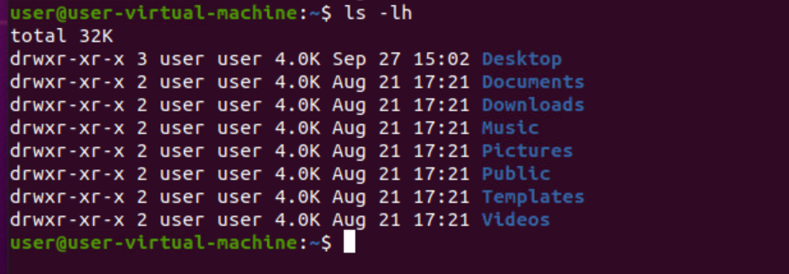

**ls -t -** It sort by modification time

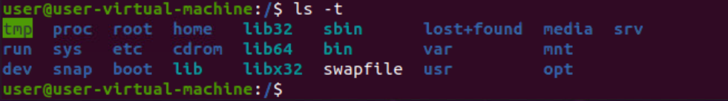

**ls -lt -** To sort the file names in the last modification time in reverse order

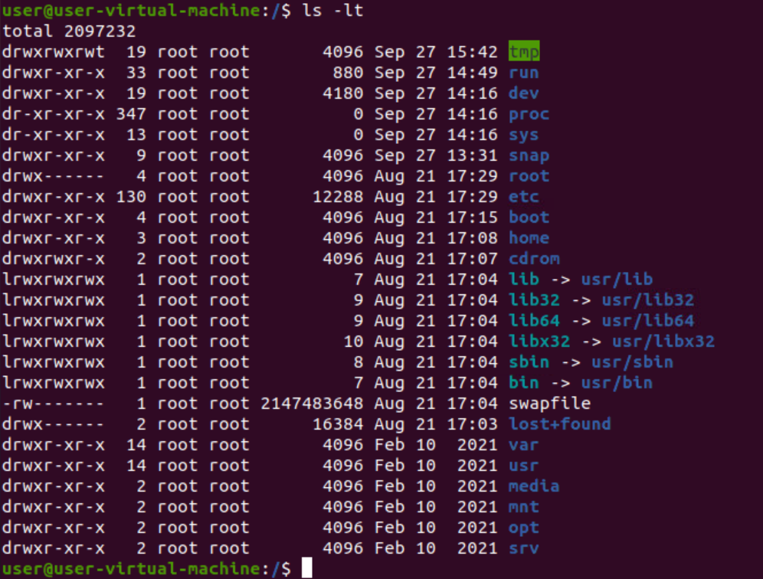

**Clear –** To clear all the terminal

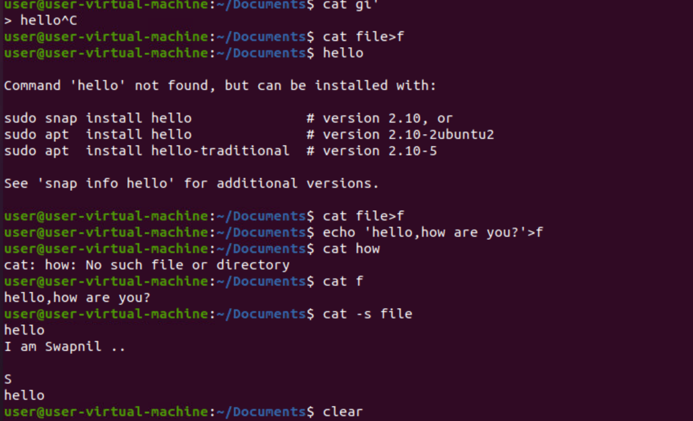

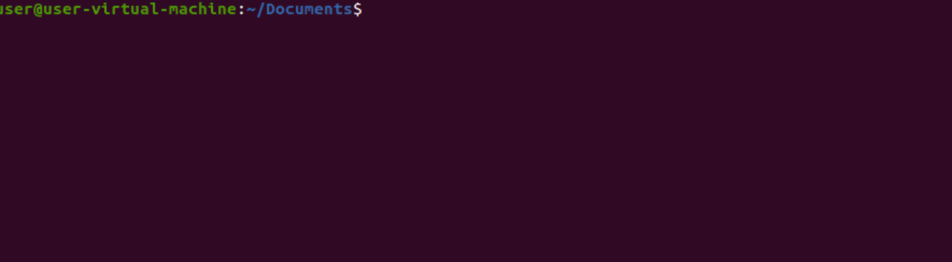

**Exit –** It is used to exit the shell where it is currently running

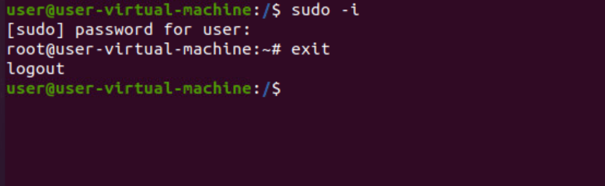

**pwd-** It prints the path of the working directory, starting from the root.

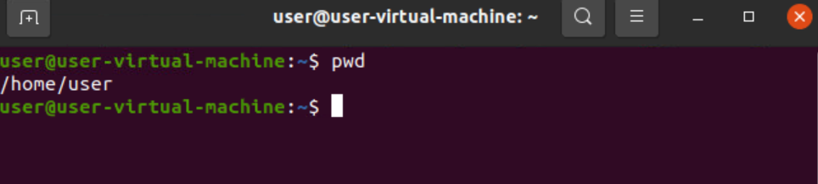

**ls -a -** list all files including hidden files.

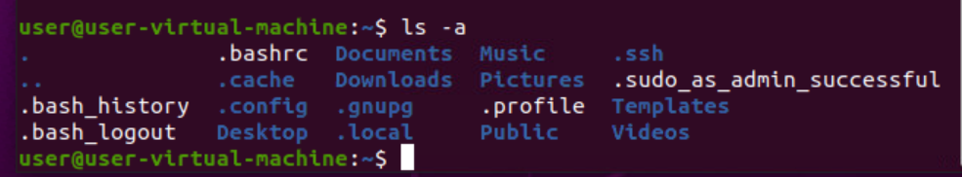

**ls -A -** list all files including hidden files except for “.” and “..” – these refer to the entries for the current directory, and for the parent directory.

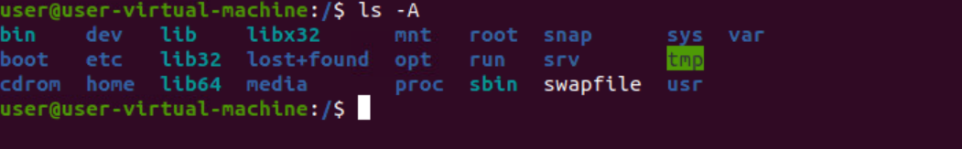

**ls ~~-~~ lr –** list all files recursively, descending down the directory tree from the given path

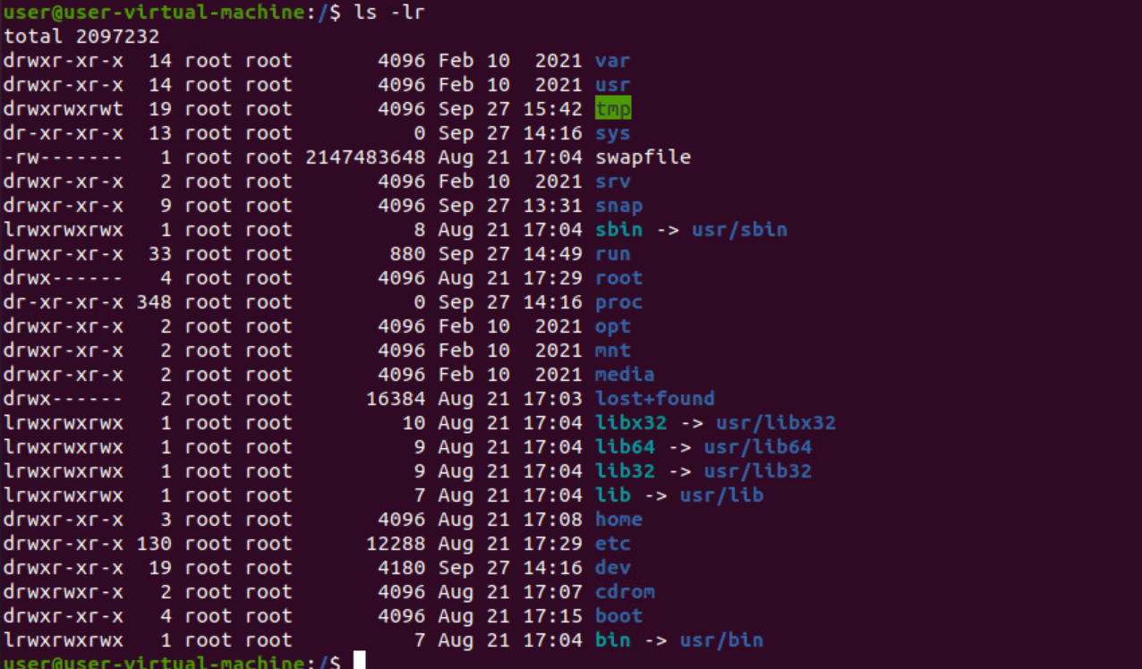

**ls -f**  - Instead of doing the ‘ls -l’ and then the checking for the first character to determine the type of file. You can use -F which classifies the file with different special character for different kind of files.

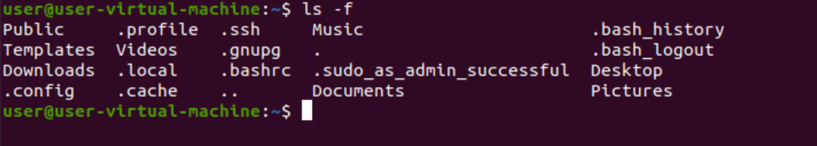

**echo “ ”** - command tool used for displaying lines of text or string which are passed as arguments on the command line



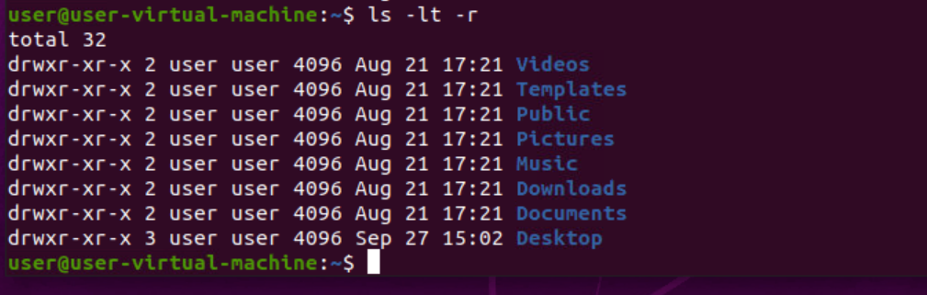**ls -ltr -** To sort the file names in the last modification time in reverse order. This will be showing the last edited file in the last line which will be handy when the listing goes beyond a page.

**Cat filename -** To view a single file

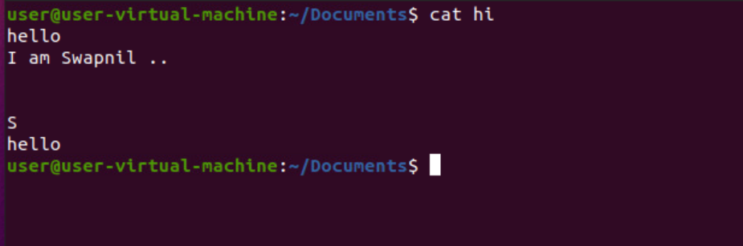

**Cat * -** Cat command to display the content of all text files in the folder

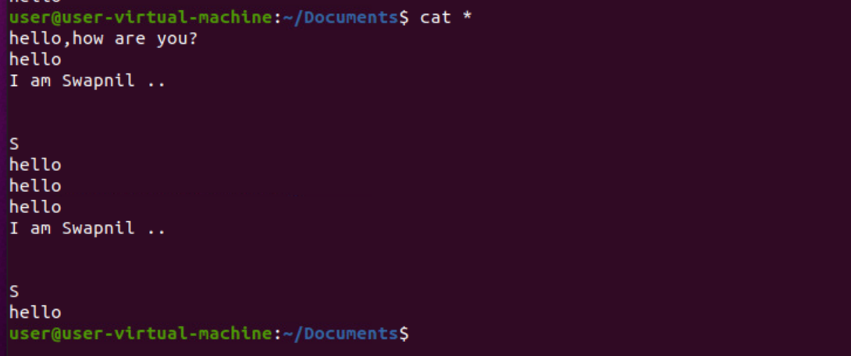

**cat -n filename -** To view contents of a file preceding with line numbers

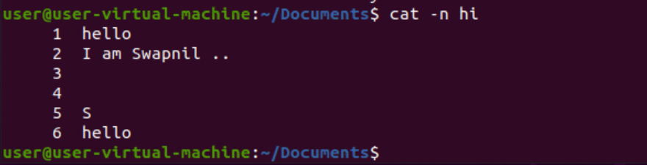

**cat file>newfile** - Create a file



**cat -n file>newfile -**

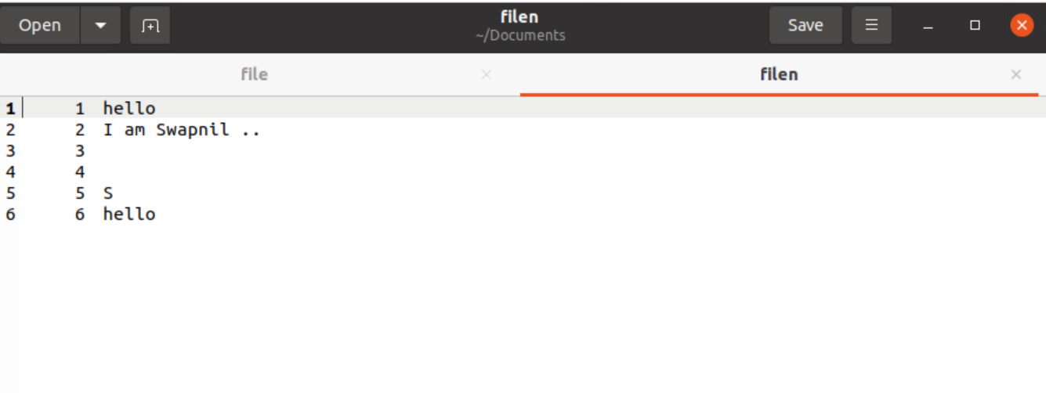

**cat f1 f2>f3** -Places concatenation of f1 and f2 in f3

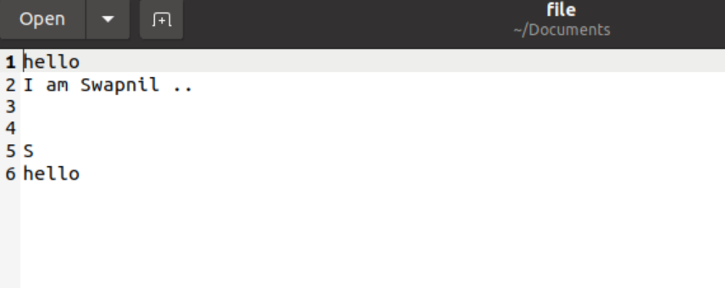

**cat f1 >> f2** - Cat command can append the contents of one file to the end of another file

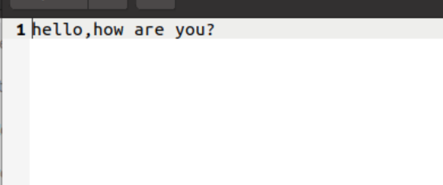

**cat -s f1** - Cat command can suppress repeated empty lines in output

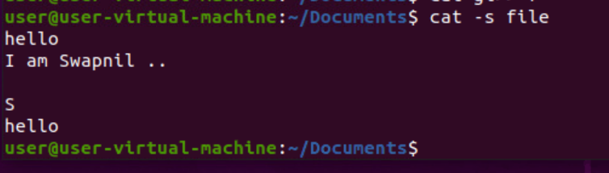

tac f1- Cat command can display content in reverse order using tac command

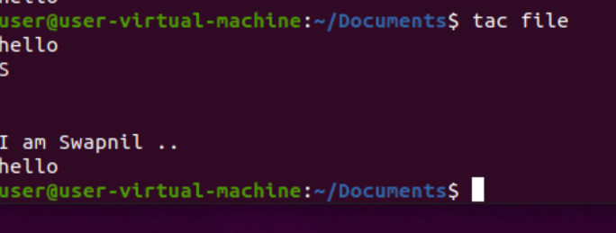

**cat -s f1>f2 -** Cat command can suppress repeated empty lines in output

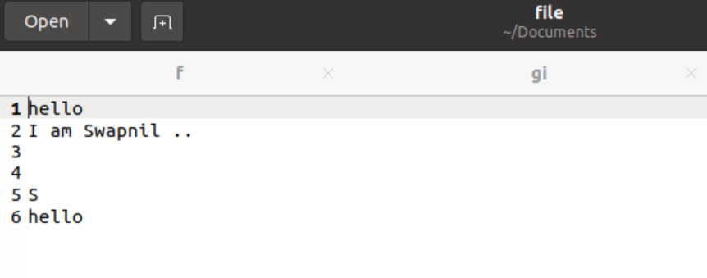

**cat -E f1 -** Cat command can highlight the end of line

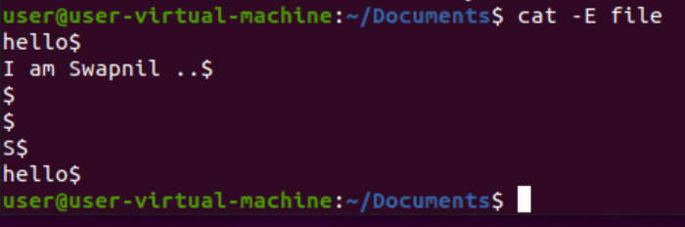

**cat -tE f1 -**

